**Project Report Template**

**BUILD AN EMPLOYEE TRAVEL APPROVAL APPLICATION FOR CORPORATES**

**1 INTRODUCTION**

**1.1 Overview**

Our organization his decided to implement a custom travel approval app. Up until now, you had a travel approval process in place based on emailing spreadsheets. It had no central repository or enforcement if the process, resulting in the inability to report on travel approval activities across the organization. You need to create an application that meets that meets these requirements:

* Each employee must submit an electronic request in the system for future travel.
* Each request includes a list of estimated expenses for airfare, hotel, rental car, and so on.
* Each request must be approved by the employee’s manager, and all out-of-state must be approved by a travel coordinator.
* Managers need reports and dashboards to track key travel request trends and KPIs.
* In addition, employees and managers must be able to access their travel requests, approvals, and dashboards via mobile device.

By the end of the project, you’ll have a working prototype of the new travel approval application. You start by creating a travel approval app that provides a view of your specific travel-related objects, which you create in the next steps.

**1.2 Purpose**

* Improving our working skills and well-being.
* Improving our language skills.
* Learning intercultural competencies.

The achievement of the project is to develop the corporates in profit and develop the skill of the employees. It leads to the company to high level.

**2 Problem Definition & Design Thinking**

**2.1 Empathy Map**

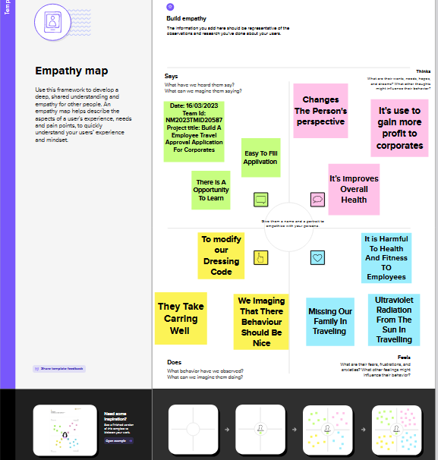

**2.2 Ideation &Br+ainstorming Map**

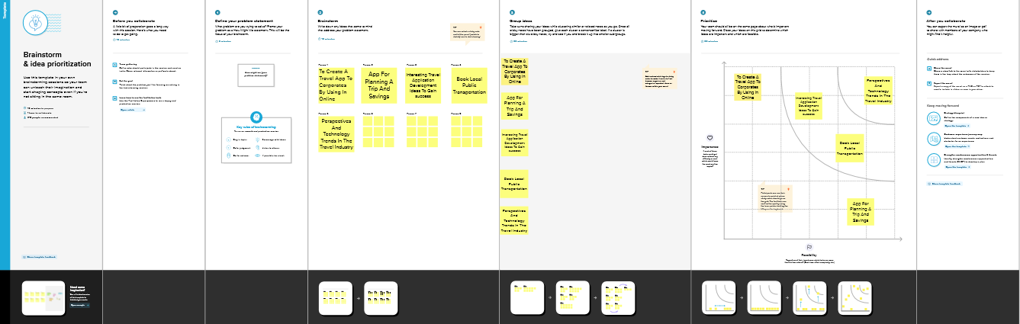

**3 RESULT**

**3.1 Data Model:**

|  |  |
| --- | --- |
| **Object name** | **Fields in the Object** |
| **Department** | |  |  | | --- | --- | | **Field Label** | **Data Type** | | Department Field | Text(80) | | Amount | Currency (16,2) | |
| **Expense Item** | |  |  | | --- | --- | | **Field Label** | **Data Type** | | Expense Item Field | Text(80) | | Expense Item | Picklist | |
| **Student** | |  |  | | --- | --- | | **Field Label** | **Data Type** | | Expense Item | Text(80) | | Amount | Currency(16, 2) | | Travel Approval | Master-detail (Travel Approval) | |
| **Travel Approval** | |  |  | | --- | --- | | **Field Label** | **Data Type** | | Department Field | Master-Detail(department) | | Destination State | Text Area(255) | | Out of State | Text Area(255) | | Purpose of Trip | Phone | | Status | Picklist | | Status Indicator | Formula (Text) | | Total Expenses | |  |  | | --- | --- | |  | Roll-Up Summary  (SUM student) | | | Travel Approval # | |  |  | | --- | --- | |  | Auto Number | | | Trip End Date | Date | | Trip Start Date | Date | |

**Milestone 1-Create Salesforce Org:**

**Activity: 1 Create Developer Account**

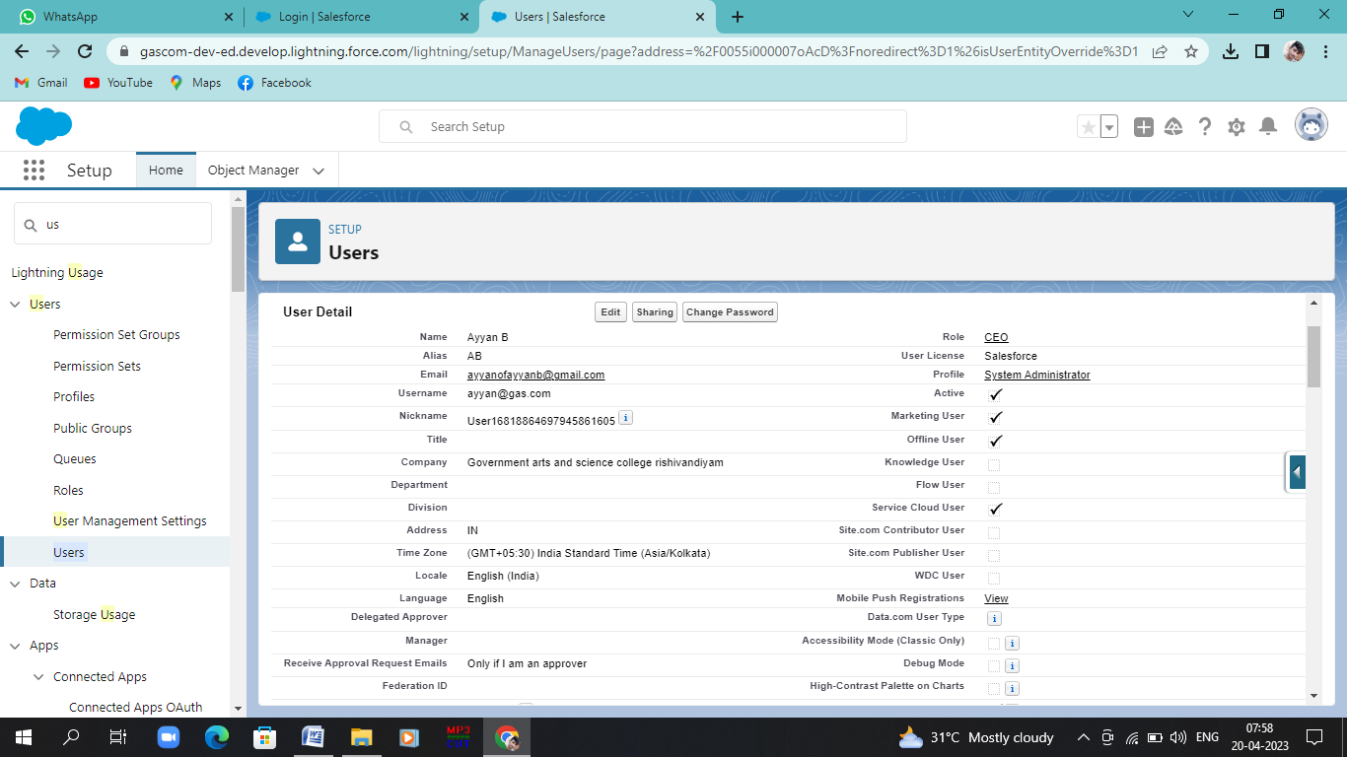

**Activity:2 Account Activation**

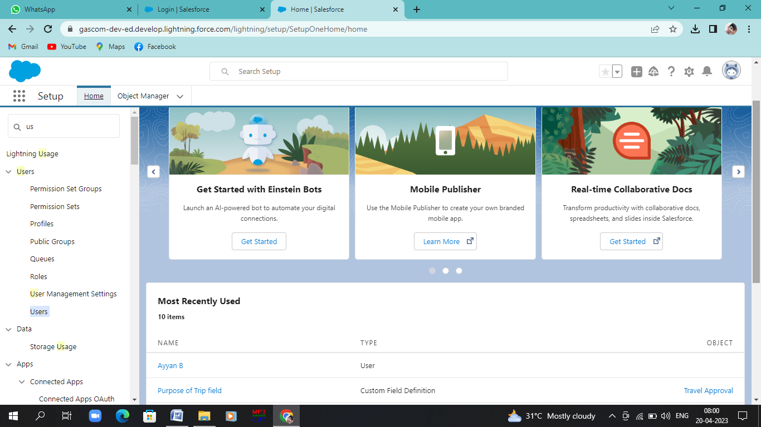

**Milestone 2-Create the Application:**

**Activity-1: Create the Travel Application**

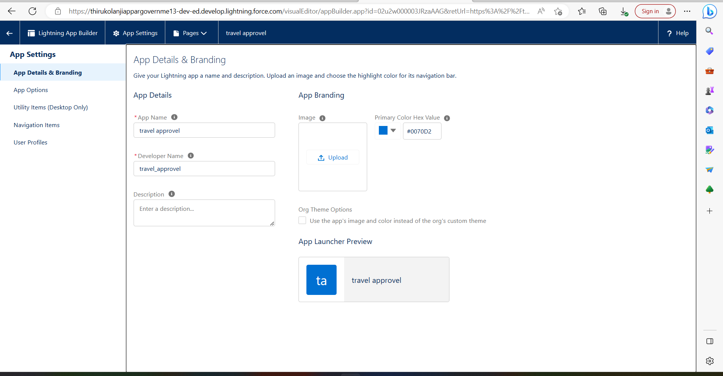

**Milestone 3-what is an Object?**

**Activity:1 Create Department Object**

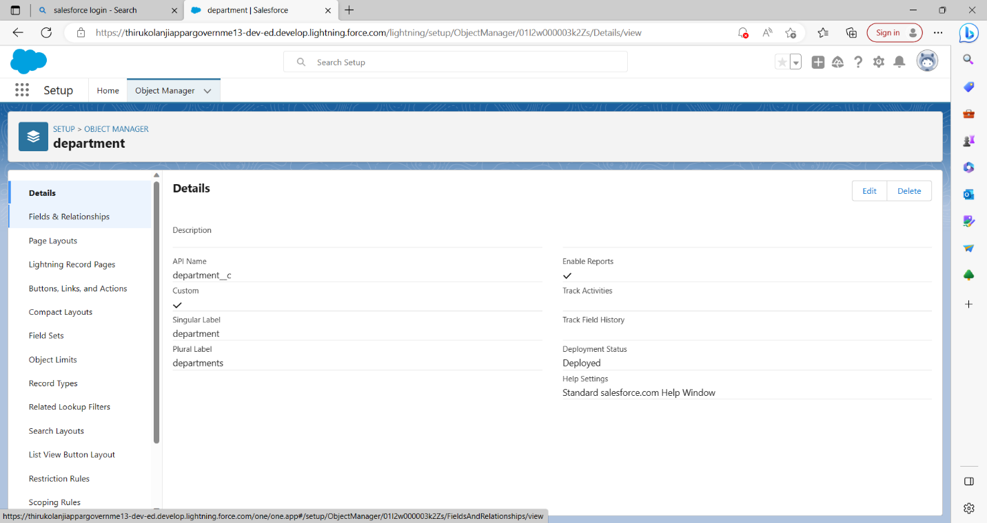

**Activity:2 Create Travel Approval Object**

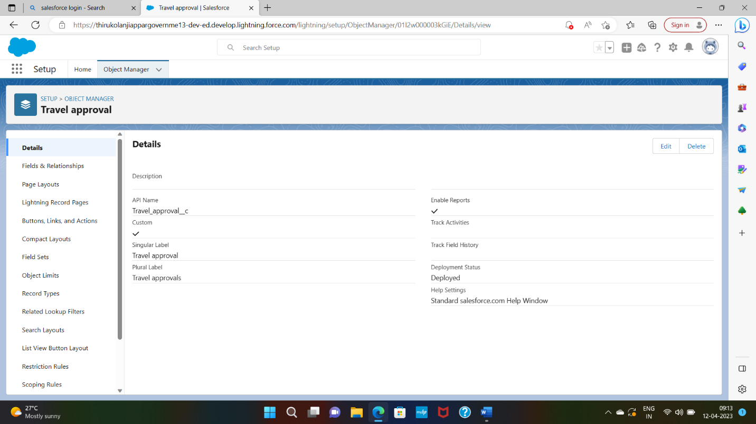

**Milestone 4-what is a Tab?**

**Activity:1 Create A Custom Tab**

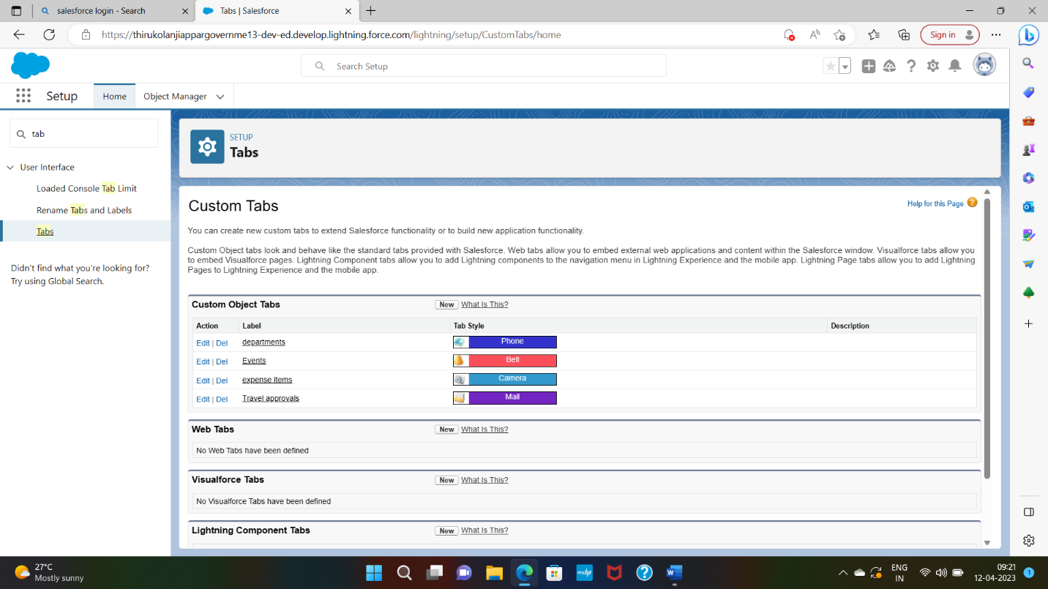

**Milestone 4-Create-Fields & Relationships:**

**Activity:1Create Fields &Relationships**

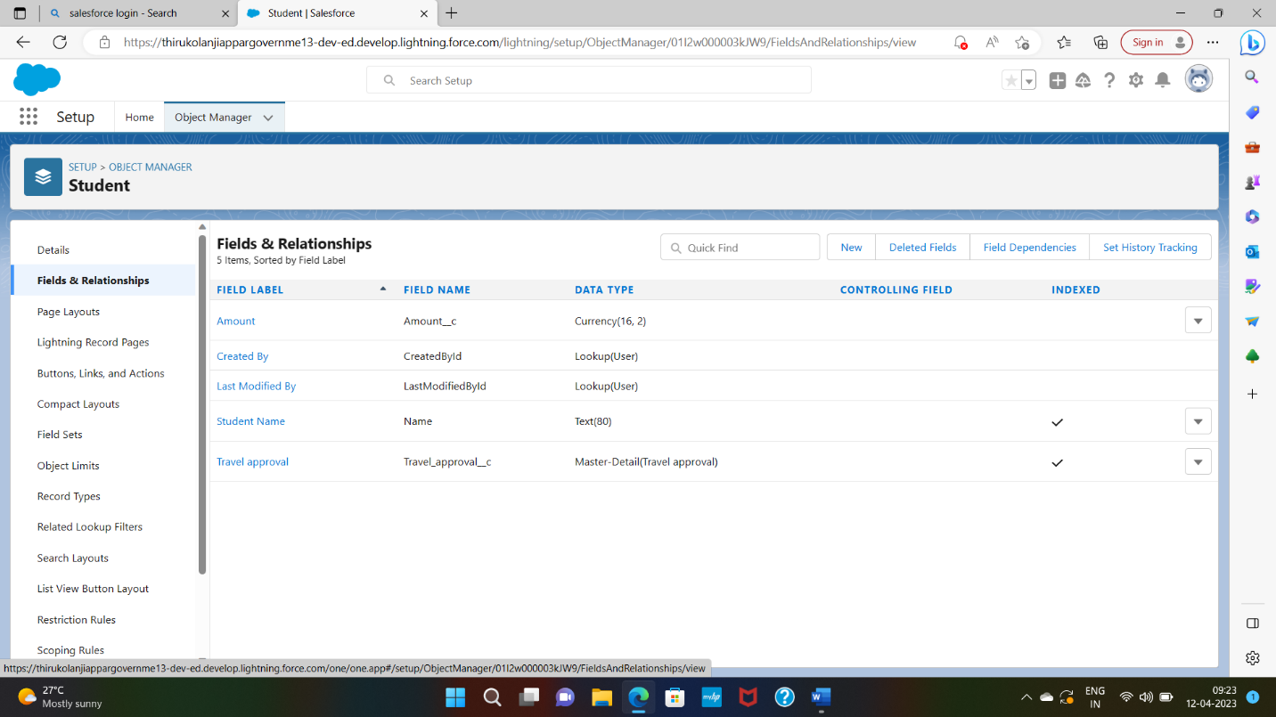

**Activity: 2**

**Create Expense Type Field**

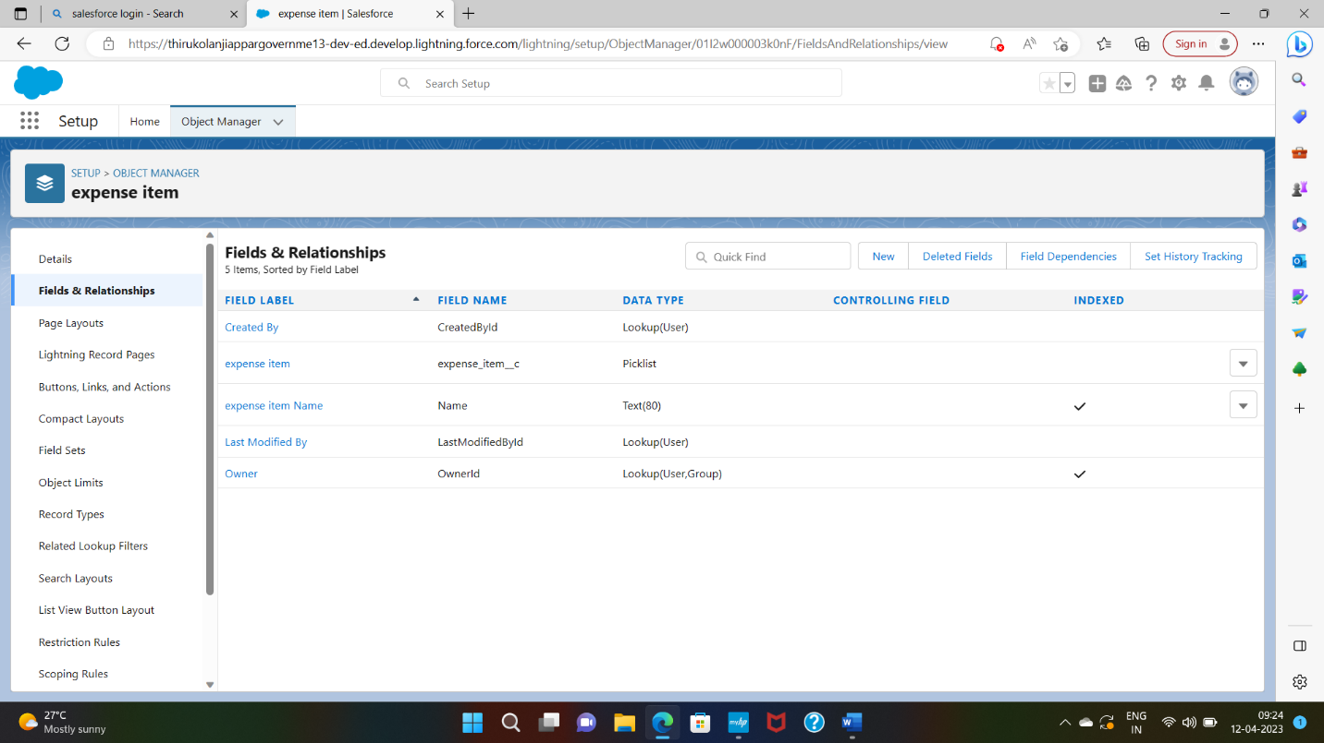

**Activity: 3**

**Create Travel Approval Field**

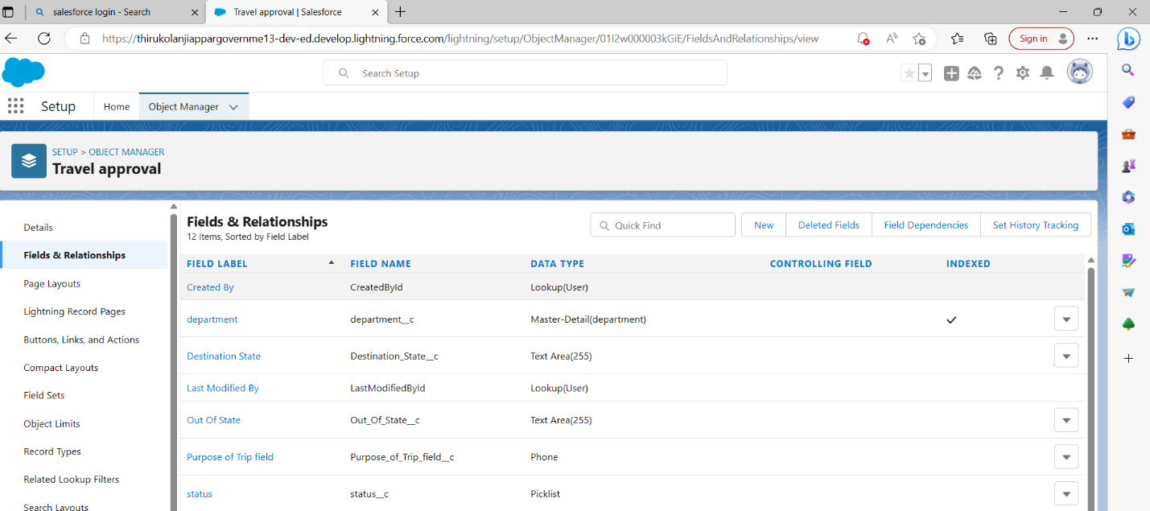

**Activity: 3.1**

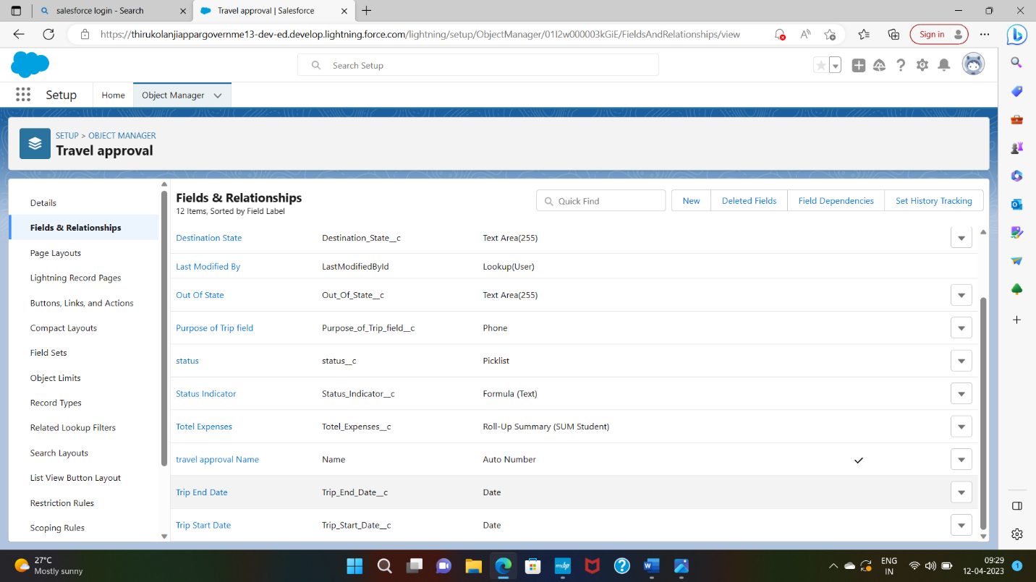

**Milestone 5-Import Departments:**

**Activity: 1**

**Import Departments**

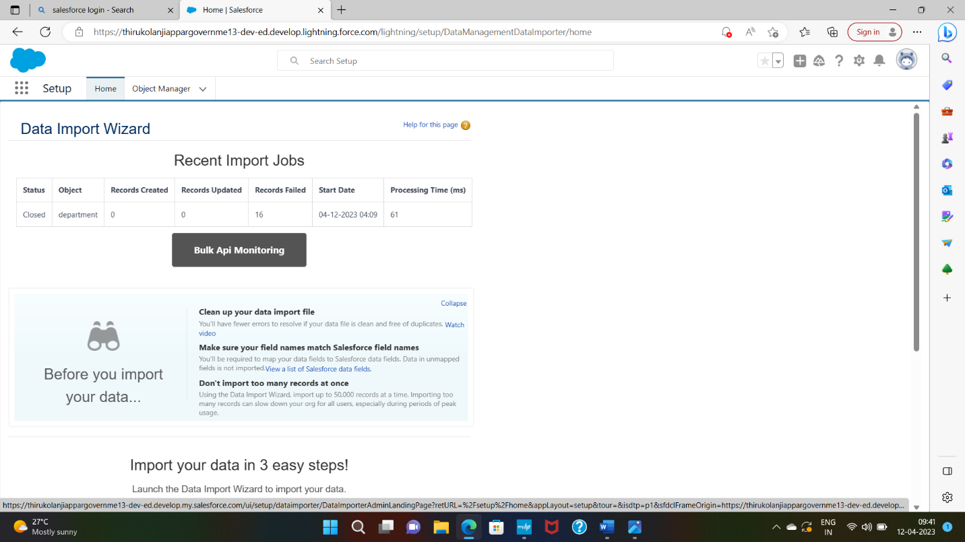

**Milestone 6-Custmize User Interface:**

**Activity: 1 Create User Setup Approvals**

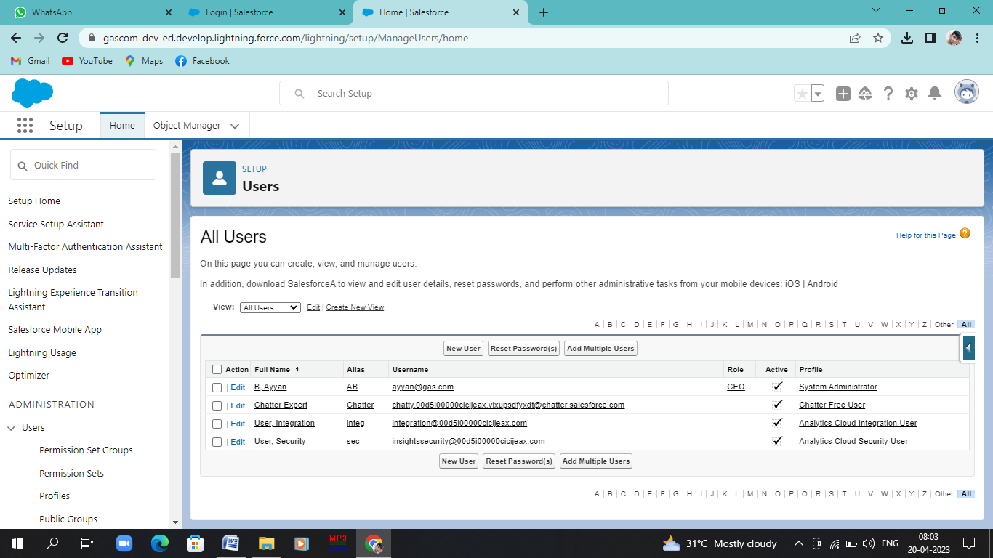

**Milestone 7-Use Customization:**

**Activity: 1Customize Travel Approval Object Page Layout**

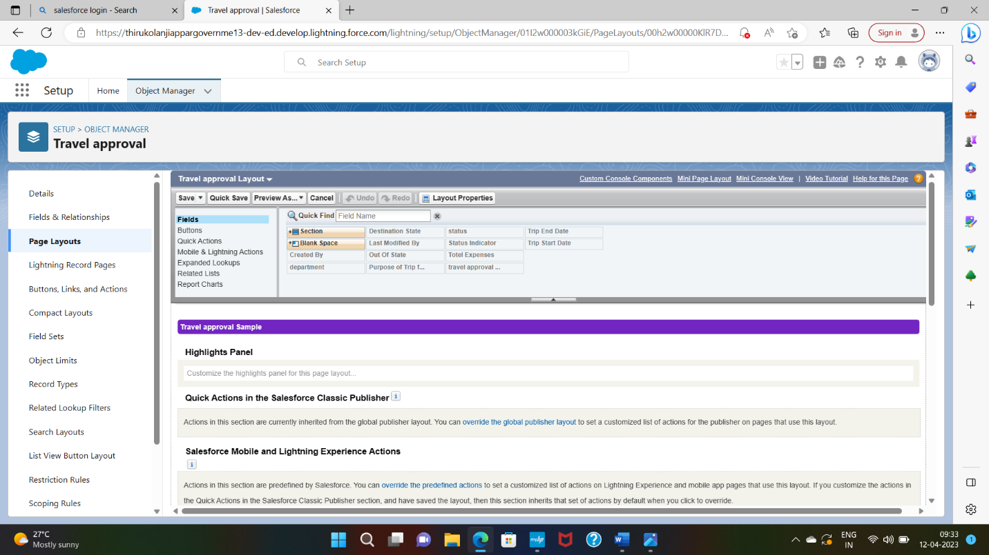

**Milestone 8-Add Business Logic to Travel App:**

**Activity: 1 Create Validation Rule**

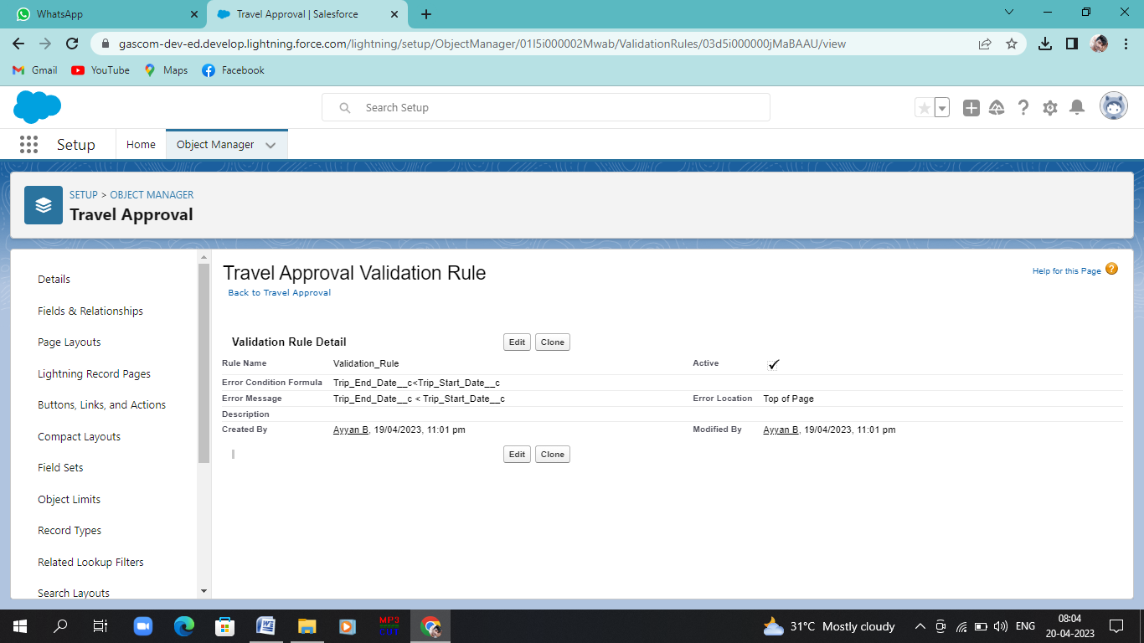

**Activity: 2**

**Create Rollup Summary Fields**

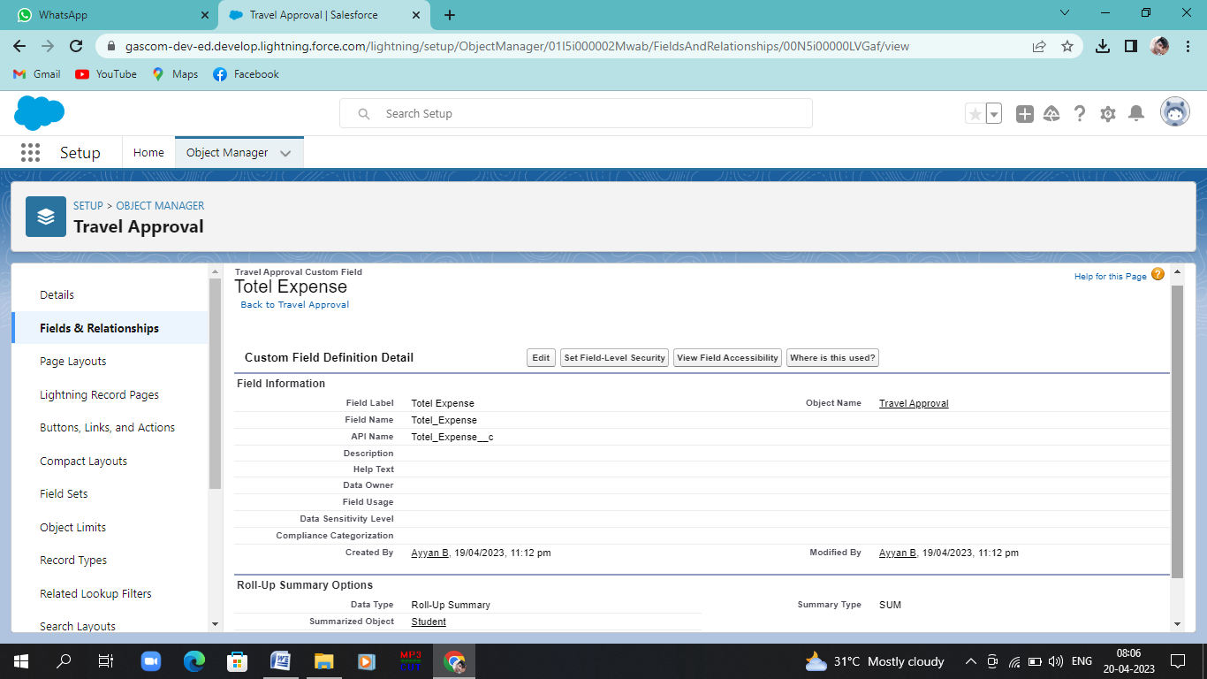

**Activity:3**

**Create Formula Fields**

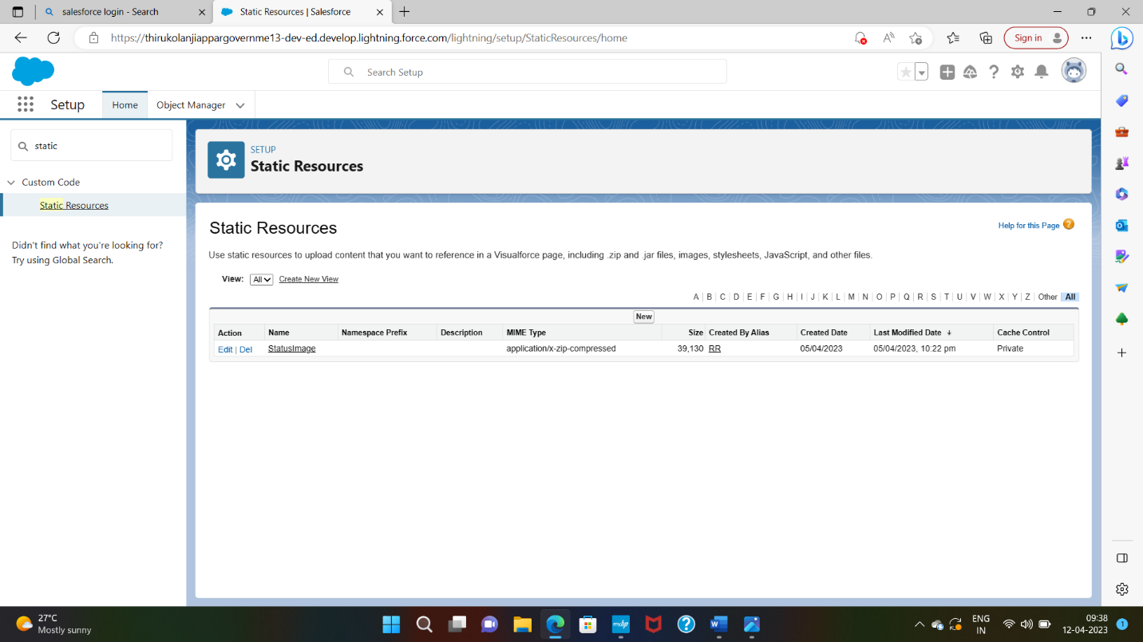

**Create Status Indicator Field**



**Milestone 10-What are Reports?**

**Activity:**

**Add Report**

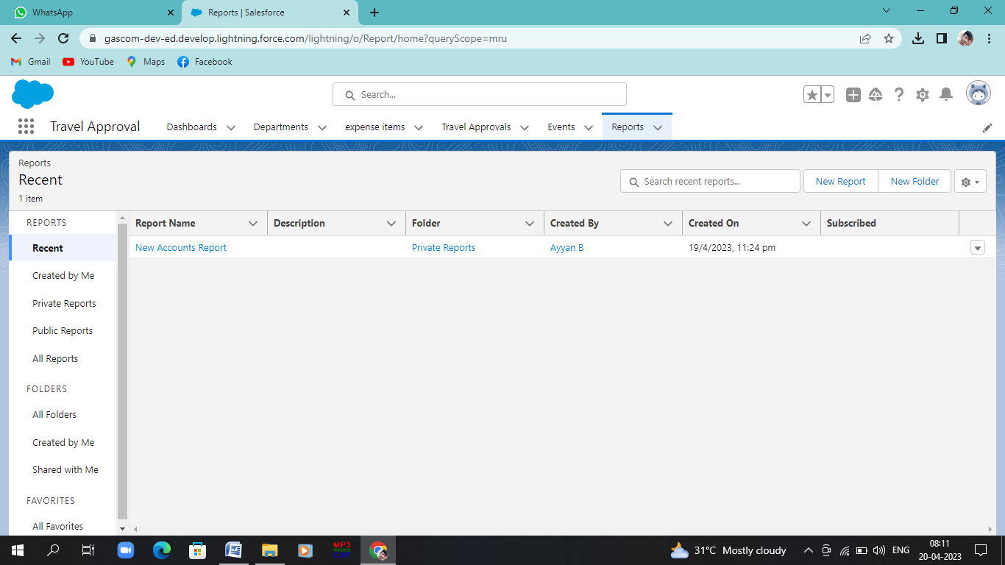

**Milestone 11-Dashboards:**

**Activity: Create Travel Approvals Dashboard**

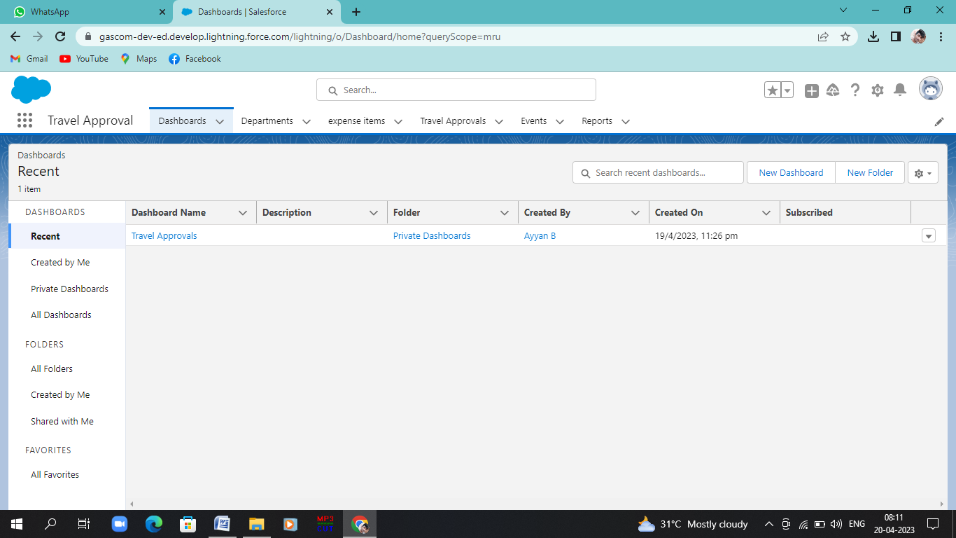

**4. Trailhead Profile Public URL**

**Team Lead –**AYYAN B

<https://trailblazer.me/id/ayyab>

**Team Member 1 –**ALAMELU P

<https://trailblazer.me/id/alamp40>

**Team Member 2 –** ANAND S

<https://trailblazer.me/id/ssanand5>

**Team Member 3 –**AYYAPPAN M

<https://trailblazer.me/id/ayyappan6603>

**Team Member 4 –** CHANDRU S

<https://trailblazer.me/id/schandru17>

**5. ADVANTAGES & DISADVANTAGE**

**Advantage:**

1. Business travel is great way to develop new skill, confident, speaking, adaptability, time management and networking
2. To achieve a peace of mind and make memories. Then we can understand our self.
3. Traveling allows us to meet people of different cultures with diverse traditions and distinctive lifestyles. This is also good for breaking the monotony of the work because meeting with new people.
4. Finding a new place and exploring the places is the central part of business travel. It helps the employees to develop the knowledge to do business operation.
5. This also gives an impact on the productivity and growth of the organization.

**Disadvantage:**

1. Business travels are expensive because companies spend a lot of money on it. Not only the plane ticket, but companies also provided hotel costs, transportation costs and food services to their employees.
2. So it is evident that business travel is dependent on the tremendous amount of money of the organization.Sometimes it creates difficulty for the small startup business organization.
3. This is the principal disadvantage of business travel, and frequent traveling can be responsible for creating significant health problems for employee.
4. Because of this employees cannot concentrate on their work, which affects the organization’s productivity.
5. Consuming unhealthy food constantly can create health problems for employees. Then it will be stressful for us or staff members.

**6. APPLICATION**

* Sample application natural one, its focus is to show natural one functionality rather than being a full-fledged for travel.
* The Travel Support System (TSS) allows us to request and approve business trips.
* Flights hostels and even more external information such as cell phone expenses or car rentals can be entered with the trip request.
* A manager can do both, request own trips as well as approve trips that have been request by employees.
* After the manager has approved single or multiple requested, the manager can print an itinerary or receive the itinerary has a file.

**7. CONCLUSION**

It is a great opportunities to learn salesforce in the topic of a Build an Employee Travel Approval Application for Corporates. In that travel for employee in a company is useful to learn and gain more knowledge. It is also useful to corporates by earning the profit nearly 20% to 50% of profit to companies.

It is useful to report by the phone immediately and give explanation for corporates or company.

**8. FUTURE SCOPE**

Travel industry is improving futuristic by including new travel trends in its ecosystem making it more feasible for the public.